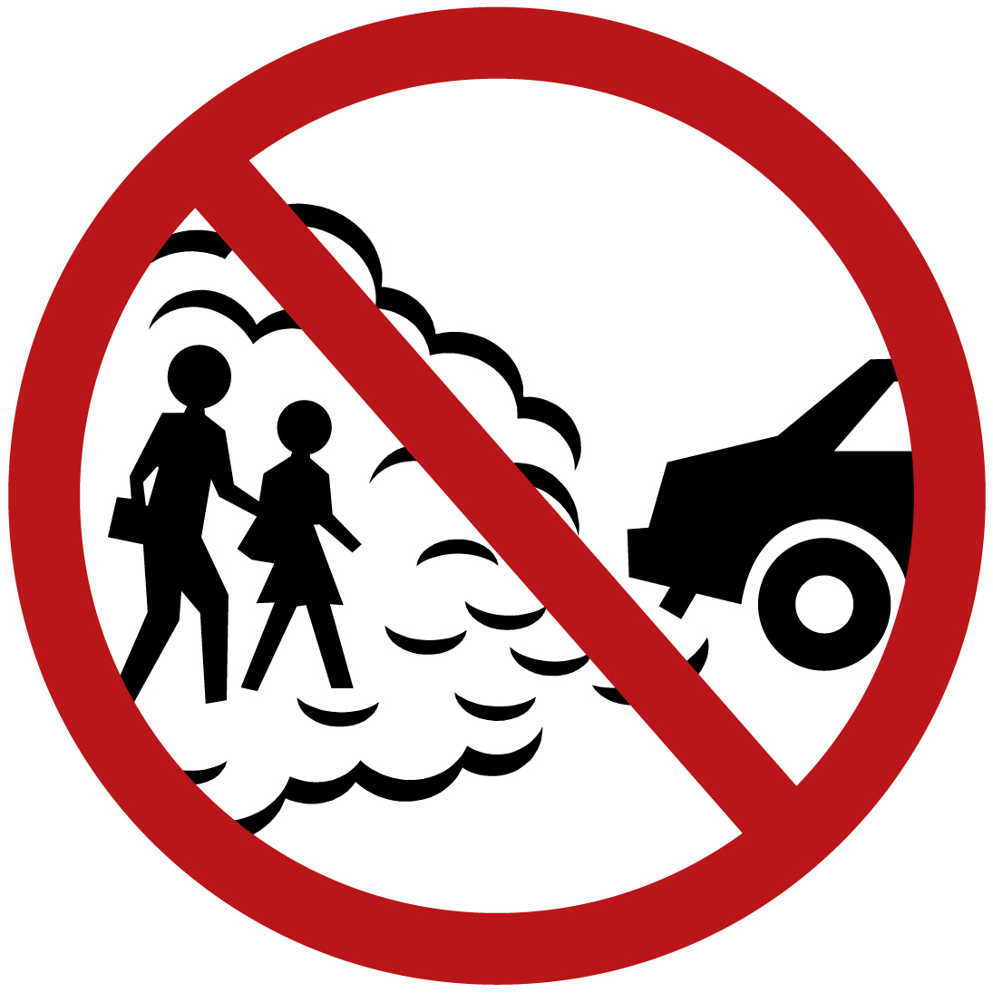**Idle Free New Jersey**

We designed these signs specifically for schools in New Jersey and have the laws applicable to idling at the bottom of the sign. The signs are sheeted with 3M HIP sheeting for durability.

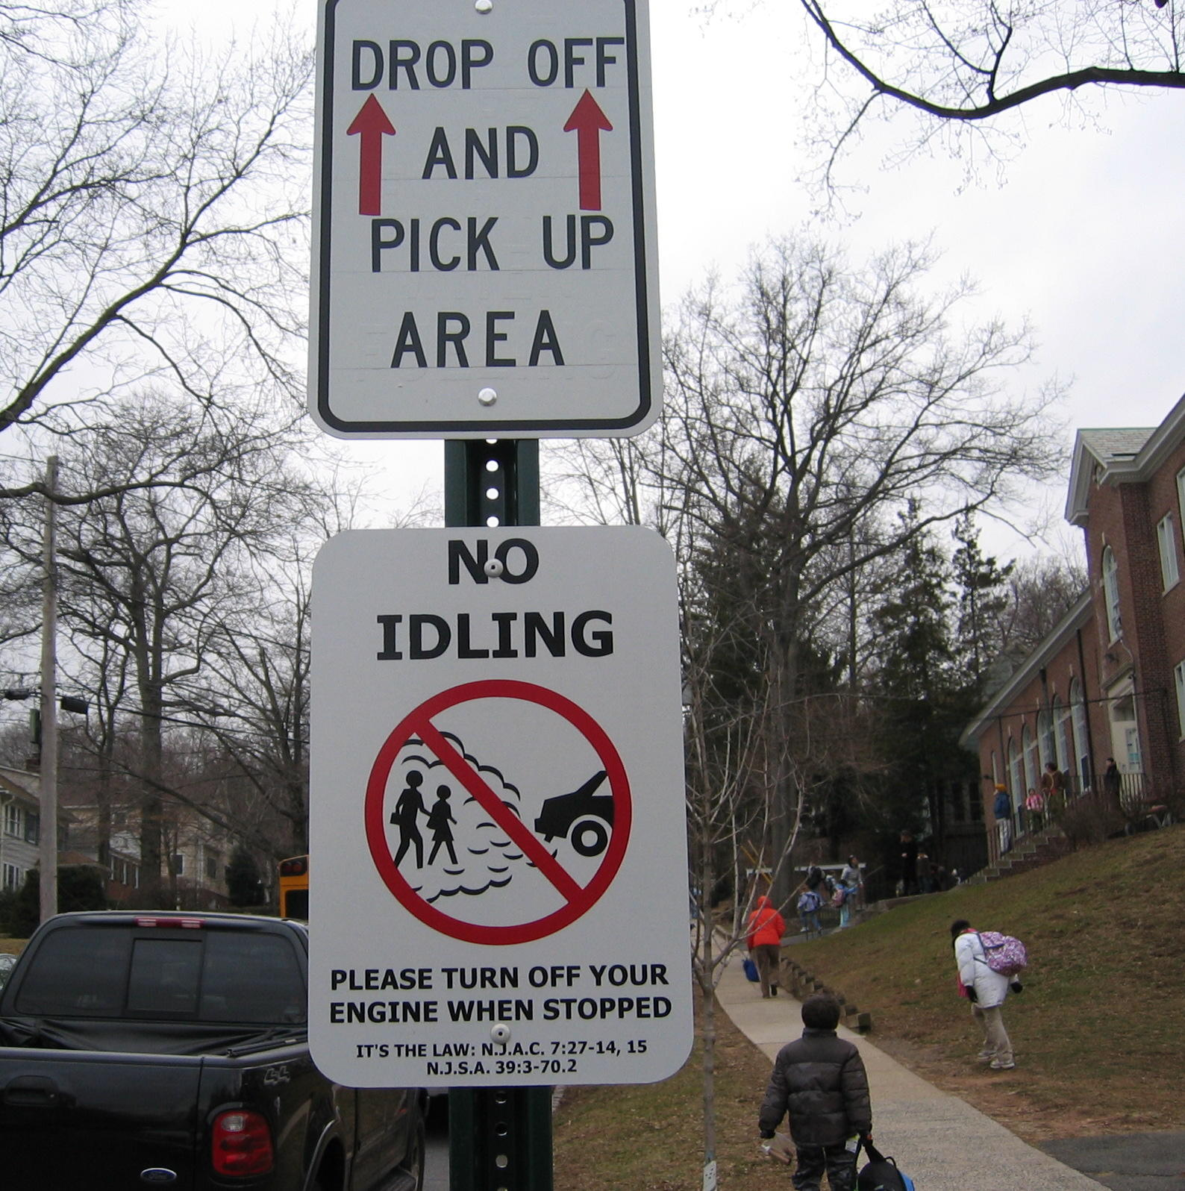

No Idling Sign at Wyoming School

**Millburn**

i

If you are interested in purchasing these No Idling signs for your location, please fill out the form below and return it with your check or purchase order made out to:

**Garden State Highway Products**

**1740 East Oak Road, Vineland, NJ 08361**

**Attention: Rob Green**

**---------------------------------------------------------------------------------**

**NAME OF ORGANIZATION:**

**______________________________________________________**

**CONTACT NAME, PHONE, AND EMAIL:**

**______________________________________________________**

**BILLING ADDRESS:**

**______________________________________________________**

**SHIPPING ADDRESS:**

**______________________________________________________**

**# of signs ___ x $___.___ per sign* = $______ Total**

* $17.66 per sign includes tax and UPS shipping to anywhere in NJ.  
$17.00 per sign for tax exempt businesses. *Must include documentation of ST-3, ST-13, or equivalent form.*$12.00 per sign for municipalities.

**Please allow 2-4 weeks for delivery.**